**Project**

The Molokai Nut Company (MNC) makes four different products from macadamia nuts grown in the Hawaiian Island: chocolate-coated whole nuts (Whole), chocolate-coated nut clusters (Cluster), chocolate-coated nut crunch bars (Crunch), and plain roasted nuts (Roasted). The company is barely able to keep up with the increasing demand for these products. However, increasing raw materials prices and foreign competition are forcing MNC to watch its margins to ensure it is operating in the most efficient manner possible. To meet marketing demands for the coming week, MNC needs to produce at least 1000 pounds of the Whole product, between 400 and 500 pounds of the Cluster product, no more than 150 pounds of the Crunch product, and no more than 200 pounds of the Roasted product. Each pound of the Whole, Cluster, Crunch, and Roasted product contains, respectively, 60%, 40%, 20%, and 100% macadamia nuts with the remaining weight made up of chocolate coating. The company has 1100 pounds of nuts and 800 pounds of chocolate available for use in the next week. The various products are made using four different machines that hull the nuts, roast the nuts, coat the nuts in chocolate (if needed), and package the products. The following table summarizes the time required by each product on each machine. Each machine has 60 hours of time available in the coming week.

|  |  |  |  |  |
| --- | --- | --- | --- | --- |
| **Minutes Required per Pound** | | | | |
| **Machine** | **Whole** | **Cluster** | **Crunch** | **Roasted** |
| **Hulling** | 1.00 | 1.00 | 1.00 | 1.00 |
| **Roasting** | 2.00 | 1.50 | 1.00 | 1.75 |
| **Coating** | 1.00 | 0.70 | 0.20 | 0.00 |
| **Packaging** | 2.50 | 1.60 | 1.25 | 1.00 |

The selling price and variable cost associated with each pound of product is summarized in the following table:

|  |  |  |  |  |
| --- | --- | --- | --- | --- |
| **Per Pound Revenue and Costs** | | | | |
|  | **Whole** | **Cluster** | **Crunch** | **Roasted** |
| **Selling Price** | $5.00 | $4.00 | $3.20 | $4.50 |
| **Variable Cost** | $3.15 | $2.60 | $2.16 | $3.10 |

**a.** Formulate an LP model for this problem (i.e., List what is the objective variable, what are the decision variables, what should be the objective function, and list the constraints in a mathematics way.)

**b.** Create a spreadsheet model for this problem, and solve it using Solver.

c. What is the optimal solution?

**Solution:-**

**a.** Formulate an LP model for this problem (i.e., List what is the objective variable, what are the decision variables, what should be the objective function, and list the constraints in a mathematics way.)

**Answer:**

Let MNC makes X₁ pounds of whole nuts, X₂ pounds of chocolate-coated nut clusters, X₃ pounds of chocolate-coated nut crunch bars, and X₄ pounds of plain roasted nuts. The cost price of each pound of whole, cluster, crunch and roasted is $3.15, $2.60, $2.16, and $3.10 respectively. The selling price of each pound of whole, cluster, crunch and roasted is $5.00, $4.00, $3.20, and $4.50. MNC wants to maximize their profit.

Therefore, the objective function for this model will be.

Max:

(5 - 3.15) X₁ + (4 - 2.6) X₂ + (3.2 - 2.16) X₃ + (4.5 – 3.10) X₄

MAX = 1.85X₁ + 1.4X₂ + 1.04X₃ + 1.4X₄

MNC wants to produce at least 1000 pounds of the whole product. Therefore,

X₁ ≥ 1000

MNC wants to produce between 400 and 500 pounds of the cluster product. Therefore

400 ≤ X₂ ≤ 500

MNC wants to produce no more than 150 pounds of the crunch product and no more than 200

pounds of roasted product. Therefore,

X₁ ≤ 150

X₄ ≤ 200

Each pound of whole, cluster, crunch and roasted product contains 60%, 40%, 20% and 100% macadamia nuts. The company has 1,100 pounds of nuts available. Therefore,

(60/100) X₁ + (40/100) X₂ +(20/100) X₃ +(100/100) X₄ ≤ 1100

6 X₁ +4 X₂ + 2 X₃ +10 X₄ ≤ 1100

The company has 800 pounds of chocolate available. Therefore,

(100 – 60)/100 X₁ + (100 - 40)/100 X₂ + +(20 - 100)/100 X₃ +(100-100)/100 X₄ ≤ 800

(40/100) X₁ + (60/100) X₂ +(80/100) X₃ +(0/100) X₄ ≤ 800

4 X₁ +6 X₂ + 8 X₃ +0 X₄ ≤ 8000

Each of Hulling, Roasting, Coating and Packaging machine has 60 hours available. Therefore,

1 X₁ + 1 X₂ + 1 X₃ + 1 X₄ ≤ 3,600

And,

2 X₁ + 1.5 X₂ + 1 X₃ + 1.75 X₄ ≤ 3,600

Also,

1 X₁ + 0.7 X₂ + 0.2 X₃ + 0 X 4 ≤ 3600

And

2.50 X₁ + 1.60 X₂ +1.25 X₃ + 1.0 X₄ ≤ 3600

**a.**

**The LP mode for this model is shown below**

**Objective Function Max Profit :**

**Max: 1.85 X₁ + 1.4 X₂ + 1.04 X₃ + 1.40 X₄**

**Subject to:**

**6 X₁ + 4 X₂ + 2 X₃ + 10 X₄ ≤ 11000 (Nuts Constraint)**

**4 X₁ + 6 X₂ + 8 X₃ + 0 X₄ ≤ 8,000 (Chocolate Constraint)**

**Also,**

**1 X₁ + 1 X₂ + 1 X₃ +1 X₄ ≤ 3,600 (Hulling Constraint)**

**2 X₁ + 1.5 X₂ + 1 X₃ + 1.7 X₄ ≤ 3,600 (Roasting Constraint)**

**1 X₁ + 0.7 X₂ + 0.2 X₃ + 0 X₄ ≤ 3,600 (Coating Constraint)**

**2.5 X₁ + 1.6 X₂ + 1.25 X₃ + 1 X₄ ≤ 3,600 (Packaging Constraint)**

**And,**

**X₁ ≥ 1000**

**400 ≤ X₂ ≤ 500**

**0 ≤ X₁ ≤ 150**

**0 ≤ X₄ ≤ 200**

**b.** Create a spreadsheet model for this problem, and solve it using Solver.

Included a set of decision variables to find the optimal pounds of each product produced in the cell range B6 to E6. Added unit profit of each ingredient in the cell range 85 to E6 and calculate the total profit using the function **SUMPRODUCT($B$6:$E$6,B5:E5)** and update them in the cell F5. The screenshot is as shown below,

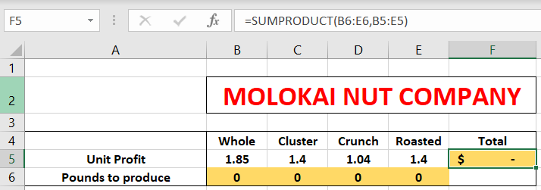

In the next consecutive rows, add all the constraints. Based on the values of decision variables, calculated the total minutes used of each machine

Calculated total minutes used of Hulling machine using the function

**=SUMPRODUCT(B6:E6,B10:E10**) and update it in the cell F10. Calculated total minutes used of other machines using the same function and copy it in the cell range F11:F13

The Screenshot is as shown below,

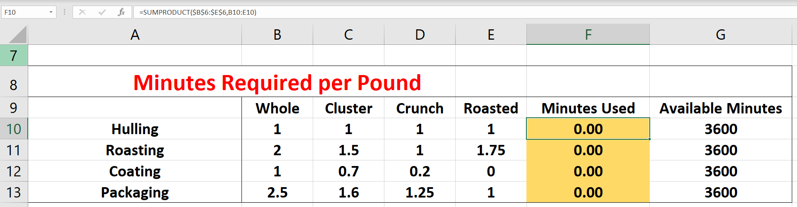

Calculate total pounds used of nuts using the function

**=SUMPRODUCT(B6:E6,B17:E17)** and update it in the cell F17.

Calculate total pounds used of chocolates using the function

**=SUMPRODUCT(B6:E6,B18:E18)** and update it in the cell F18

The screenshot is as shown below.

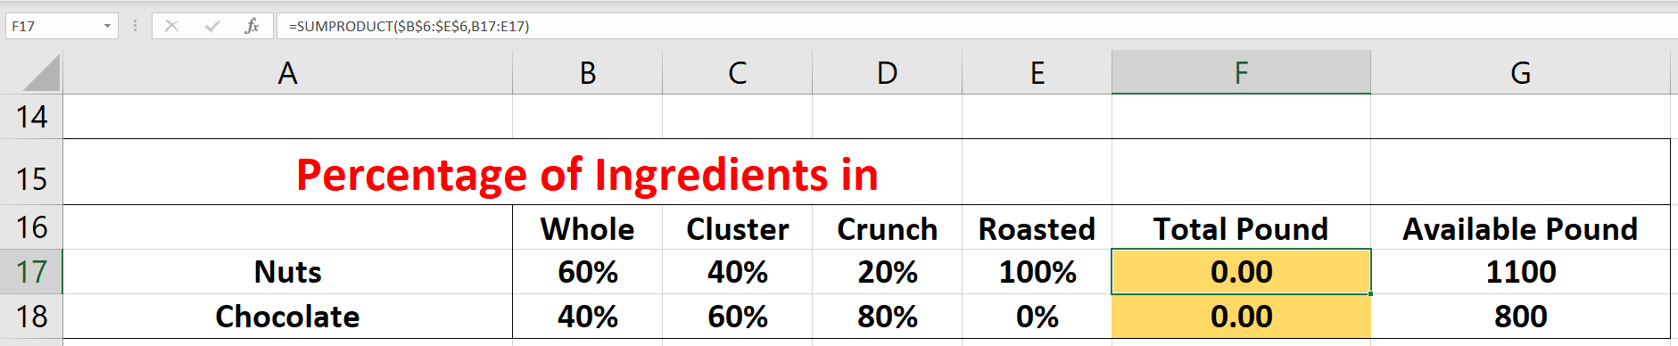

Insert minimum pounds required of each product in the cell range B20:E20 and maximum pounds required of each product in the cell range B21:E21

The spreadsheet model for the above problem is shown as below:

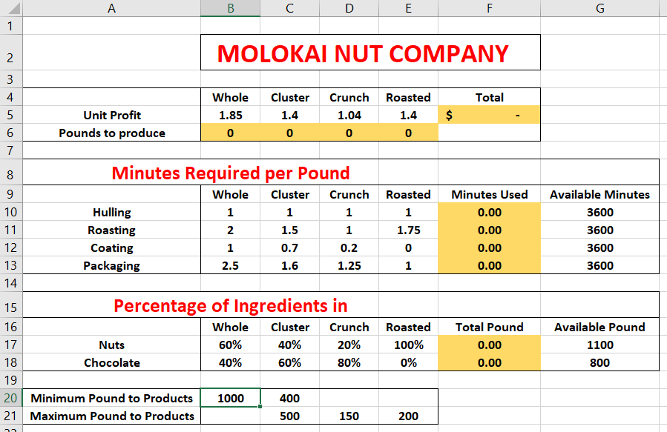

Find the optimal solution using Solver.

Define the constraints in the text field named "Subject to the Constraints" These constraints can be input by clicking on the Add button, and then a dialog box will appear. Define the machines constraint.

Click Add button, Define the ingredients constraints.

Click Add button. Define the minimum amount of each ingredient in the trail mix,

Click Add button. Define the maximum amount of each ingredient in the trail mix

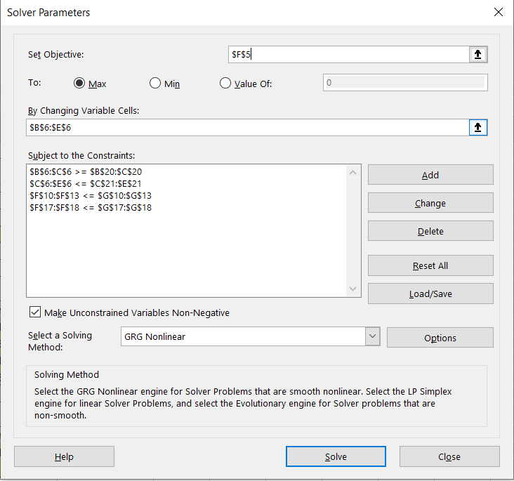

Click OK and then the Solver dialog box will return After clicking on Solve button, a dialog box will appear saying that the solution has been found.

If the "Keep Solver Solution option button is clicked, the values of the decision variables will be updated automatically,

The screenshot is as shown below

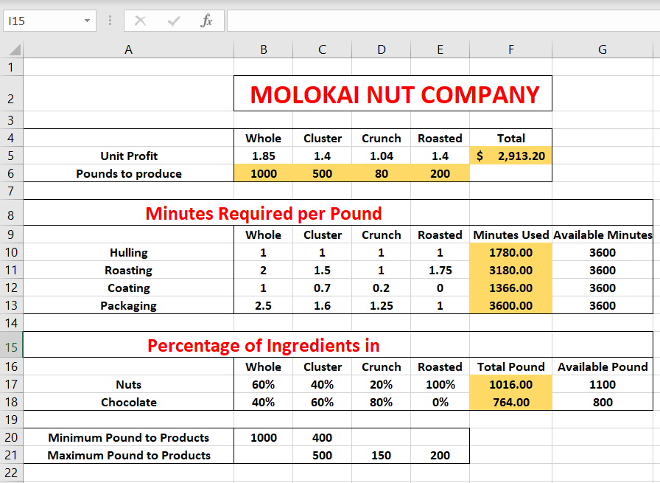

c. What is the optimal solution?

Based on the solver report, the optimal solution of this problem is

X₁ = 1000 pounds, X₂ = 500 pounds, X₃ = 80 pounds, X₄ = 200 pounds

and the objective value is $ 2,913